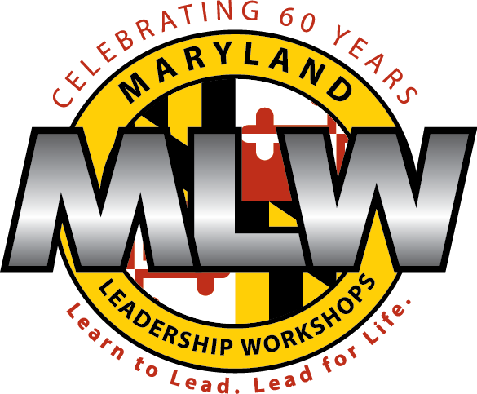

Dear 2015 MLW Middle School Experience in Leadership (MSEL) Delegate and Family Members:

We are very excited to welcome you to our program and are thrilled that you will spend a week with us this summer! Check-in starts at 1:30 on Sunday, July 19 and pick up is on Saturday, July 25 at 11:15am. Please see the enclosed information for more details, including a packing list and the address for Washington College.

Our staff has spent the last two months training and preparing for the week ahead. Dolly Parton once said, "If your actions create a legacy that inspires others to dream more, learn more, do more and become more, then, you are an excellent leader." For 60 summers, our goal has been to empower our delegates to embody the actions of a leader during our program and beyond.

Maryland Leadership Workshops teaches delegates about leadership through experience, inquiry, and discussion. Instead of simply telling our delegates how to use leadership skills in different situations, you are given opportunities to experience new challenges firsthand. Though the utilization of your own experiences, strengths, and working with your fellow MLW team members you will be able to build new skills and gain information to achieve your goals. The MLW staff facilitates the learning process by using guiding questions and allowing delegates to create your own understanding through experience. Not to mention, the program is a lot of fun!

Please share this letter with your parents/guardians as it contains important information regarding logistics for pre-site preparation, check-in and operations during the week as well as more detailed medical information. Most importantly, take a few minutes to complete the MLW MSEL Pre-Site Leadership Inventory survey at:

https://www.surveymonkey.com/s/MSEL2015PRE

If you do not have access to the internet, you will be able to complete the survey on the first day of the program. Please feel free to contact the MLW office if you have any questions.

Thanks for your help to make this a great experience for everyone. We look forward to seeing you soon.

Shanika Rawlings and Adrienne Carlisle
MSEL Directors

MLW SHW Pre Site Survey and Committees/Seminars

Every delegate is asked to complete the Pre-Site Survey to provide MSEL staff with important information about you! Please go on line and complete the survey at:

https://www.surveymonkey.com/s/MSEL2015PRE

One item you will be asked is on which committee you would like to work. Below are descriptions of the various options. We will try to accommodate your requests to the greatest extent possible but your first choice is not guaranteed.

The survey will only take about 10 minutes to complete and should be done before July 2.

Committee choices include:

Closing Activity Committee/Ceremony
Members of this committee will plan a closing activity for the end of the week as well as the final ceremony to end our MSEL week. The purpose of the activity is to wrap up and reflect on the delegates’ week at MLW.

Community Service Committee
Members of this committee will select an issue that they decide is important to young people and plan a program-wide community service activity related to that issue. This committee is restricted to returning MSEL delegates.

Awareness and Empowerment Committee
Members of this committee get to choose a social issue and raise awareness about the issue throughout the week. The purpose of this committee is to teach the delegates to properly spread awareness.

Newsletter Committee
Members of this committee will plan and create a newsletter about the week at MLW. The final product will be distributed to parents during the mid-week and end of the week newsletter from the MLW Executive Director.

Variety Show Committee
Members of this committee will plan the MLW Variety Show. All MLW delegates and staff will be invited to participate in the show (you do not have to be on the committee to perform; being a member of the committee does not mean you have to perform).

PRE-SITE, CHECK-IN, AND ON-SITE LOGISTICS

Pre Site

Pack a reusable WATER BOTTLE. Summer can be hot in Chestertown and we want everyone to stay hydrated. If you have a water bottle with your name on it, please bring it with you.

Bring a small backpack or bag to use to carry around books, pens, etc.

Do not bring electronics (ipods, tablets, laptops, or games). There is very little time to use these devices which must be left in dorm rooms. MLW is not responsible for the loss or damage of these devices, so it is best to leave them at home.

Mobile phones are allowed if a student wants to be able to call home at recreation/free time or before lights out; MLW is not responsible for loss or damage of phones. Mobile phones are not permitted in workshops or at any organized activities and will be confiscated by staff if used inappropriately or at inappropriate times during the day. If you prefer to leave your phone at home, you can always use the phone in the office to call home or bring some postcards or letter writing materials and send a letter instead!

Please review the rules and guidelines of the week at Washington College, which were a part of your application packet. Most importantly, students are not allowed off campus.

MLW will have some merchandise for sale. Other than those optional items, students will not need any money while at MLW.

Registration

Check-in at Washington College begins at 1:30 and runs to 2:15 p.m. on Sunday, July 19. The address is 300 Washington Avenue, Chestertown, Maryland, 21620. Enter campus at Greenwood Ave. (not Campus Drive) and follow the road to the parking lot of Gibson Center for the Arts, which will be on your left. Washington College will have signs posted for parking and registration. Please leave suitcases and sheets/towels/pillows in your car until you have checked in and received your room assignment.
If you have any kind of medication whether it is prescription (RX) or over the counter (OTC) medicine including things like vitamins, please bring it to the registration and be sure to check-in with the nurse. All medicine should be in its ORIGINAL container and prescription medicine must match the physician's orders on the medical form from the application. See the “Important Medical Information” page for more details.

Parent Meetings

There will be a brief parent meeting on Sunday at 2:30 in the Decker Theater of the Gibson Center for the Fine Arts building to tell parents about the week ahead. Please stick around for that meeting if possible. There will also be a Closing Ceremony at the end of the week which we encourage you to attend. The Closing Ceremony will be held on Saturday morning, July 25, at 10:30 also in the Decker Theater. Delegates will be dismissed at the conclusion of the Closing Ceremony (at 11:15 am). Please leave travel time for beach traffic which can be heavy on the weekends. There will be a late pickup fee for students not picked up before noon.

Staying in Touch

Emails will be sent from MLW to parents during the course of the week. If you do not hear from MLW, please contact the office so we can be sure to include you in the list.

If you would like to contact the MLW office during the week, please email office@mlw.org or call our main number 301-444-8623 which will forward to the campus office.

To send a letter to your student, please use the following address and send everything before Wednesday of the week to ensure delivery.

DELEGATE NAME — MSEL
Maryland Leadership Workshops
Washington College
300 Washington Avenue
Chestertown, MD 21620

IMPORTANT MEDICAL INFORMATION
As part of the program application, EVERY delegate should have submitted a physician- and parent/guardian-approved Medical Administration Authorization form for all prescription and non-prescriptions medications that s/he is bringing to MLW, plus the other general health information forms. You will not be admitted on site unless we have your medical forms. Please contact the office if you are having difficulty with them. We also encourage you to make a copy of the medical forms for yourself.
If there are any changes to your original forms, changes must be made in writing on the approved MLW medication forms and must include the delegate’s name, parent/guardian signature, date signed, the medicine name, the reason for medicine, and documentation indicating that at least one dose of medication was given at home. Blank forms can be found at http://www.mlw.org/blog/wp-content/uploads/2015/04/2015-Medical-Forms.pdf
MEDICATION
Delegates must turn in ALL medication (prescription AND over the counter) to the Health Consultant at registration. Per the State of Maryland Department of Health and Mental Hygiene Youth Camp regulations, MLW staff keeps medication in the office. The exceptions to this are epi-pens and inhalers.
All medications must arrive in their original containers. For prescriptions, this means as prepared by pharmacy complete with pharmacy prepared labels that are consistent with the prescriber’s order (i.e.,the medication must match the prescription order attached). Over the counter medicine should be in its original container.
If you take medicine on a regular basis:
Delegates come to the office at designated times to self-administer medication under the supervision of MLW staff. Delegates are only permitted to take medication (prescription or over the counter) for which there is a health care provider’s signature. Please be sure to provide one Medication Administraton Authorization Form (p. 5 of the medical forms packet) for each prescription and non prescription medication that you will be sending with the delegate, and obtain the necessary signatures on each form.
IMPORTANT CHANGES FROM LAST YEAR REGARDING OVER-THE-COUNTER MEDICATION
DUE TO NEW DHMH REGULATIONS, MLW STAFF IS NO LONGER ALLOWED TO PROVIDE OVER-THE-COUNTER MEDICATION. The only medication delegates will be allowed to take is what you send with him/her, and only if the enclosed Medication Administration Authorization form (p. 5 of the medical forms packet) is filled out and signed by you and your health care provider for each medication.
To clarify: you must provide one Medication Administration Authorization Form (p. 5 of the medical forms packet) for each medication, whether prescription or non-prescription. Please make copies of this form as needed, or request more copies from office@mlw.org.

Using Prescription and Non-Prescription Medications On Site:
Only delegates who have obtained the necessary health care provider signatures on the MLW forms will be allowed to take medicine while at MLW.
While at MLW, a delegate who is taking any medication on a regular basis will come to the MLW office each day at the designated time (breakfast, lunch, dinner, bedtime) to take pre-approved medications.
Delegates will be supervised during their medication intake, but the MLW staff expects that all delegates are capable of self-administering medication. If this is not the case, call the MLW office at (301)-444-8623 immediately.
If a delegate is feeling ill, they will come to the office and parents will be contacted. No medicine will be administered unless the delegate brought it him/herself along with the Medical Administration Authorization form signed by a health care provider.
Medical Emergencies:
If any delegate experiences any significant health difficulties during the program his or her parent/guardian will be notified immediately, and the delegate may be taken to the Kent & Queen Anne's Hospital which is located directly behind the campus. 911 may also be called. The delegate’s file, including medical emergency contact information, health history and insurance information will be taken with them.
Emergency Personnel:
As part of its Maryland Youth Camp certification, Maryland Leadership Workshops is required to employ at least two full-time, residential staff members who are certified in CPR and First Aid. Certifications for these staff members are kept on file in the MLW office and are available upon request.
Additionally, Washington College Campus Security is trained in CPR, First Aid, and AED use.

MLW PACKING LIST

- Enough comfortable, weather appropriate clothing for the week. Your clothes should be school-appropriate; if you wouldn’t be allowed to wear it at school, please do not bring it to MLW. Staff and delegates wear casual, comfortable clothing, so bring shorts, t-shirts, jeans, sneakers, and a sweatshirt, as we’ll be both inside the air conditioning and outside in the summer heat.

- There will be a variety show/showcase that delegates will plan and implement. Please bring any instruments, equipment, or anything else that will help you share your talent with the rest of the MLW community.

- There will also be an opportunity to teach a class on a topic of special interest to you. Special interests that students have shared have ranged from origami and drawing to free style rap and hip-hop. Most students end up facilitating a session, so bring any materials (like origami paper or hip-hop music) that will help you!

- Flashlight

- Sheets for an extra-long twin bed (and/or a sleeping bag) and a blanket (the dorms are air conditioned so it can get cold)
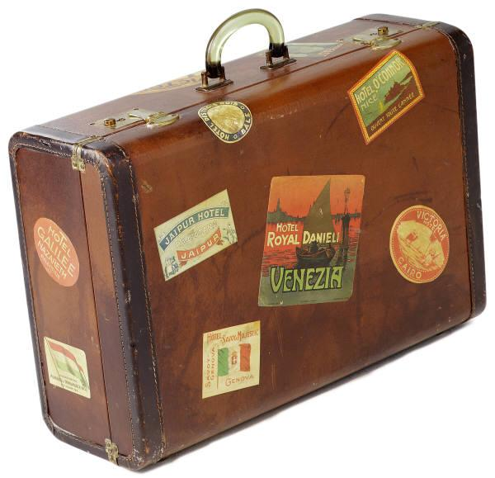
- Pillow

- Towels
- Toiletries (don’t forget a toothbrush, toothpaste, handsoap, shower soap, and deodorant)
- Shower Shoes
- A rain jacket/umbrella
- Alarm Clock
- Pens or pencils
- A reusable water bottle
- A small bag or backpack to carry guidebook, pen, water bottle, etc.
- Clothing for messy games
- A “dressy” outfit for the Closing Ceremony
- Athletic equipment: tennis shoes, Frisbee, Football, etc…
- Light snacks and drinks for evenings.

