Review Guide for ALS
Maryland Leadership Workshops

P.O. Box 1792
Germantown, MD 20875
301.444.8623
www.mlw.org

S-­‐Specific
SMART Goals

What specifically do you want to achieve?

M-­‐Measurable
What steps will you make to achieve your goal?

A-­‐Action Oriented
How will you achieve those steps?

R-­‐Realistic
Is your goal realistic?

T-­‐Timely
What is your deadline?

Why does MLW encourage using SMART goals? What is the purpose?

How do you personally check in with your goals? When do you do so? Why?

What is one SMART goal you have for yourself at ALS 2014?

Idea Generating Strategies
1-2-3 - Come up with an idea that is one-word, next idea should have two words, the next three and so on.

ABC’s - Come up with one idea starting with each letter of the alphabet.

Brainstorming – Members of a group call out and write down all ideas as people think of them.

Competitions – Split your group into teams. Teams compete to come up with the most ideas (for example: Marker Race), or the goofiest ideas, or several sets of rhyming ideas.

Interviewing- Everyone in the group goes out and interviews “X” number of people to get ideas. Then the group comes back and shares the results of their interviews.

Magazine Flipping – Have one magazine, newspaper or book for every member of your group. Everyone flips through looking at pictures, captions, and headlines, they write down any interesting ideas or triggers as they go.

Piggybacking Game – One person shares an idea. The next three people have to come up with an idea that adds to the previous idea, or they have to come up with an idea that uses one word from the previous idea. Then start again with a new idea.

Research – Group members look back over records left by previous students who completed similar projects, use library resources to come up with project ideas, ask advisors for input, etc.

Snowstorm - Members of a group write down ideas on a piece of paper then everyone crumples up their paper and throws it in to the middle of the group…then group members take turns picking out ideas and sharing them.

Swap Shop – When trying to decide on a project, group members share stories with each other about successful past projects.

Whip – Members of the group sit in a circle and each person shares one idea in turn.

Create two additional unique brainsotrming strategies. Explain them and talk about a good time to use them.
1.)

2.)
Place these steps into their appropriate stage of PPIE.

Set goals, Determine available resources, Create method of organization, Write out plan, Check in with organization method, Keep track of feedback for the future, Get approval, Create an evaluation tool, Check timelines, Make list of necessary materials and gather, Distribute tool and solicit feedback, Plan for possible conflicts (i.e. Troubleshoot), Generate ideas, Be aware of rising conflicts and apply troubleshooting strategies

Plan

Prepare

Implement

Evaluate

o Task Oriented
▪▪ Facilitator – Guides conversation and ensures all participants
have an opportunity to speak
▪▪ Elaborator – Explains ideas within a group, offers examples to
clarify ideas
▪▪ Connector – Shows the relationships between ideas
▪▪ Standard Setter – Suggests standards or criteria for groups to achieve and keeps the group on task with the established criteria
▪▪ Group Observer – Keeps records of group activities and uses
this information to offer feedback to the group

o Conflict Management
▪▪ Encourager – Praises the ideas of others
▪▪ Harmonizer – Mediates differences between group members
▪▪ Progressor – Works to push the group towards making
decisions and completing it’s tasks
▪▪ Energizer – Stimulates the group to a higher level of energy

o Individualistic
▪▪ Follower – Goes along with the group and accepts the group’s
ideas
▪▪ Aggressor – Attacks other group members, deflates the status
of others, and other aggressive behavior
▪▪ Blocker – Resists movement by the group
▪▪ Recognition Seeker – Calls attention to him or herself
▪▪ Dominator – Asserts control over the group by manipulating
the other group members
▪▪ Apathetic – Doesn’t care, or at least outwardly does not show
any motivation, and therefore does not contribute

St a g e s o f G r o u p

De v e l o p m e n t

Stage 1: Forming

Group Members
-­‐ Rely on safe, patterned behavior and look to the group leader for guidance.
-­‐ Desire acceptance by the group and need to know that the group is safe.
-­‐ Gather impressions about the similarities and differences among group
members and form preferences for future sub grouping.
-­‐ Keep things simple and to avoid controversy by avoiding serious topics and
feelings.
-­‐ Attempt to become oriented to the tasks as well as to one another.
-­‐ Discuss the scope of the task and how to approach it.

Stage 2: Storming
Group Members
-­‐ Compete and conflict with one another.
-­‐ Are challenged to bend and mold their feelings, ideas, attitudes, and beliefs
to suit the group organization.
-­‐ Desire structural clarification and commitment from fellow group members.
-­‐ Question who is going to be responsible for what, what the rules are, what
the reward. system is, and what criteria for evaluation are.
-­‐ Some members may remain completely silent while others attempt to
dominate.
-­‐Decisions within the group are difficult
-­‐Team members attempt to establish their own position and place within the
group

Stage 3: Norming
Group Members
-­‐ Engage in active acknowledgment of all members’ contributions,
community building, and solving of group issues.
-­‐ Are willing to change their preconceived ideas or opinions.
-­‐ Actively ask questions of one another.
-­‐ Share leadership and dissolve cliques.
-­‐ Begin to experience a sense of group belonging.
-­‐ Share feelings and ideas, solicit and give feedback to one another.
-­‐ Feel good about being part of an effective group.

Stage 4: Performing
Group Members
-­‐ Work independently, in subgroups, or as a total unit with equal ability.
-­‐ Adjust their roles and authorities dynamically to fit the changing needs of the
group.

-­‐ Are self-­‐assuring and the need for group approval is past.
-­‐ Are both highly task oriented and highly people-­‐oriented.
-­‐ Identify completely with the group, experiencing high group morale and
group loyalty
-­‐ Support experimentation in solving problems and an emphasize achievement. The overall goal is productivity through problem solving and work.

Stage 5: Adjourning/ Mourning
Group Members
-End tasks and relationships
-Recognize participation and achievement
-Say personal goodbyes

Do groups always progress through these stages in a chronological manner? Describe a time when a group may jump from one stage to another out of order.

Why is it important to be able to recognize what stage a group is in? What is the relationship between what group role you play and what stage of group development your group is in?

What DiSC Are You??

Below are adjectives and/or phrases. For each set of 4 (each line going across), choose the adjective or phrase that best describes you. Add the end of the assessment, count the number of phrases/adjectives you have circled in each column and put the total in the bottom row. You can only choose one adjective/phrase per line. Be honest with yourself!

Strong-Willed | Persuasive | Kind | Humble
Independent | Sociable | Pleasant | Cooperative
Bold | Lively | Loyal | Passive
Competitive | Cheerful | Obliging | Open-Minded
Daring | Humorous | Calm | Precise
Pioneering | Trusting | Lenient | Tolerant
Persistent | Entertaining | Obedient | Neat
Energetic | Sociable | Lenient | Peaceful
Risk Taker | Good-Mixer | Patient | Precise
Determined | Energetic | Self-Controlled | Systematic
Aggressive | Charismatic | Good-Natured | Careful
Restless | Talkative | Controlled | Conventional
Decisive | Popular | Neighborly | Organized
Adventurous | Friendly | Moderate | Receptive
Brave | Inspiring | Submissive | Shy
Motivated by  responsibility and achievement | Motivated by  recognition and personal appraisal | Motivated by time,  space and continuity to do things properly | Motivated by attention  to detail, perfection and truth
Strong focus on task  and forceful style can upset people | Emphasis on image &  relationships can neglect substance | Dependence on  process can become resistance | Need for perfection  can obstruct or delay
Fears failure and loss  of power | Fears rejection and loss  of reputation | Fears insecurity and  change | Fears inaccuracy and  unpredictability
High sense of personal  worth | Optimistic | Pragmatic | Accurate & precision
Fear – being taken  advantage of | Fear – social rejection | Fear – loss of stability | Fear – Criticism of  your work
Motivated by  Directness | Motivated by social  recognition | Motivated by  established practices | Motivated by  adherence to standards
Get it done | Be appreciated | Get along | Get it right, accuracy
Asks “what” questions | Asks “who” questions | Asks “how” questions | Asks “why” questions
Direct | Spontaneous | Friendly | Meticulous
Bottom-line, profit and  achievement | Fun, travel and  position | Helping people,  building friendships and appreciation | Value, excellence and  consistency
Do it now, do it  quickly | Put it off until later,  make it fun | Get help from others,  use traditional methods | Do it yourself, do it  properly
D: | I: | S: | C:

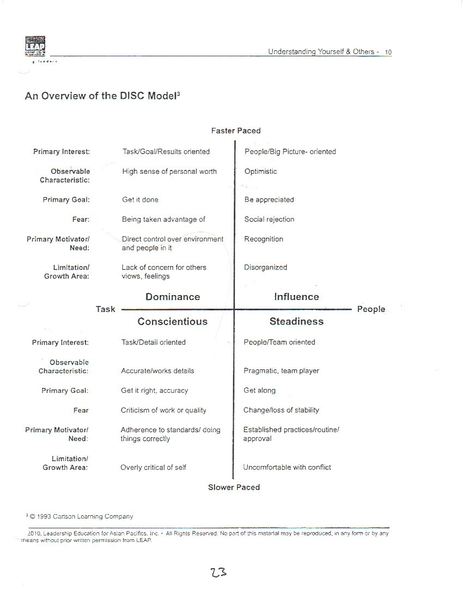

What do you agree/disagree with about your DISC results?

Discuss a time you worked with someone with a different style from your own. What benefits and challenges did it present?

Mot i v a t i o n a n d E mpo w e r men t

Define the following:

Motivation:

Empowerment:

Apathy:

Explain how motivation, empowerment, and apathy relate to one another.

How t o Beat A pathy
● Root cause of apathy: Lack of Information
○ Solution: Review current information with them; help explain how that information affects them
● Root cause of apathy: Lack of feeling part of the group
○ Solution: Bring that person into your circle in the group; introduce other members of the group to help foster a collaborative environment
● Root cause of apathy: Belief that task does not matter
○ Solution: Persuade them using any combination of ethos, pathos, logos; make the task relevant to their life
● Root cause of apathy: Lack of effectiveness
○ Solution: Empower that person by teaching them a new skill that will be beneficial to the group
● Root cause of apathy: Resentment about working in an involuntary group
○ Solution: Remind them that all members of your group are in a similar situation;
remind them of the importance of the task; connect the task to their life

Com m u ni cat i on Ter m s
Verbal Communication ~ sending a message using words

Non-Verbal Communication ~ sending wordless messages

Informal Communication ~ when a message is crafted without strict adherence to rules, convention, & etiquette

Formal Communication ~ when a message is crafted that adheres to an established set of rules, convention, & etiquette

You can be a good listener (an active listener) by:

making EYE CONTACT with the speaker

NODDING your head when appropriate

show appropriate EMOTIONAL RESPONSES

speaker

listen,
PARAPHRASE (repeat in your own words) what the

has said: “So what I hear you saying is…”

BE PRESENT for the speaker (Does he/she want you to

give advice, tell your own story, etc.

The Building Blocks of Communication: Feedback

Giving feedback allows people to hear information about skills they do well and skills they can improve upon. Giving feedback occurs in three parts, just like a sandwich:

Cookie

Filling

Cookie
Positive

Constructive

Positive

The COOKIE is the positive statement you make and the FILLING is the
constructive (area to improve) statement you make.

The POSITIVE statements surround the CONSTRUCTIVE statement so
your audience starts and leaves with a good feeling, but they still get the
point about what they can work on.

Provide feedback on the ALS Application process, both positive and constructive.

What other factors or elements should one consider when giving feedback?

Definitions

PERCEPTION– an idea formed as a result of one’s interpretation of information gained from the senses

PREJUDICE– unfavorable opinion or feeling formed beforehand or without knowledge, thought or reason

DISCRIMINATION– negative treatment of an individual or group based on real or perceived differences

STEREOTYPE– generalizations about a group of people

PRIVILEGE– a special advantage, right, or benefit granted to or enjoyed by an individual or class of people; some privileges are natural or acquired

Diversity Journal

What characteristics make you unique?
Ideas: honesty, intelligence, loyalty, friendliness, etc.

What roles do you play in your everyday life?
Ideas: sibling, friend, listener, educator, etc.

Name some qualities that make you a valuable group member.
Ideas: ability to speak in public, computer skills, communication skills, etc

How do you think other people perceive you?
Ideas: leader, shy, confident, etc.

Moving a group towards INTEGRATION

• Encourage and facilitate self-­‐awareness within the group

• Provide opportunities for open discussion of diversity and its
importance to the group’s process and product

• Create a safe space, through ground rules and low-­‐ to high-­‐risk team building activities, to allow honesty and trust between team members

• Delegate tasks using awareness of members’ strengths and challenges; individual team members can work to their strengths, step up and support each other

©Maryland Leaders 17

The Rungs of the Diversity Ladder
hip Workshops, Inc, 2014
ed. The material contained within this guidebook may not be copied without written pe

n permission

hip Workshops, Inc, 2014
ed. The material contained w

Integrate!

Empathize

Accept

TOLERATE

Discriminate

Integrate:
When the group includes all the members’ strengths and varying experiences to develop the work; the group is therefore stronger for it I apply your individual strengths and the group is better for it!

Empathize:
The group understands and accommodates for the differences, challenges, and strengths of all the members; however, these factors are not all embraced in the group’s work
I embrace that which makes you different!

Acceptance:
Diversity in the group is recognized and all the members are treated
similarly
I don’t think less of you because you’re different.

Tolerate:
Members are treated with respect, but diverse needs and traits are
ignored
I’ll work with you, but I won’t necessarily like it. or
We’re all the same. (individualism and potential issues not addressed)

Discriminate:
Treating members of a group in a different manner based on the
category that they belong instead of merit
I won’t work with you for x reason.

Think of a time you were in a group that was in the “integrate” stage. What did that
look like? How did the group get to the integrate stage?

The Decision Making Model

1. Identify the problem or the decision, how important the decision is, and the time frame the decision needs to be made in.

2. Focus on your goal while using your values and ethics as a guide.

3. Identify all possible solutions, outcomes and consequences of each solution, and possible challenges to making the most effective decision.

4. Make your decision!

5. Evaluate the decision making process.

On the following page is a personal decision-making model, work through it with a sample decision you have to make within the next year.

How might the process of making a decision change if you are making a group decision verses a personal decision?

Situation/Problem:

MY OVERALL GOAL:

DECISION ONE:

PROS
DECISION TWO:

CONS CONS

PROS

DECISION MADE:

EVALUATION:

What questions do you have about any of this review material?

What feedback do you have for the ALS Staff on this review packet? Bonus points for providing positive and constructive feedback!

